Project Name :
Multi-Environment AWS Infrastructure Automation with Terraform & Jenkins CI/CD

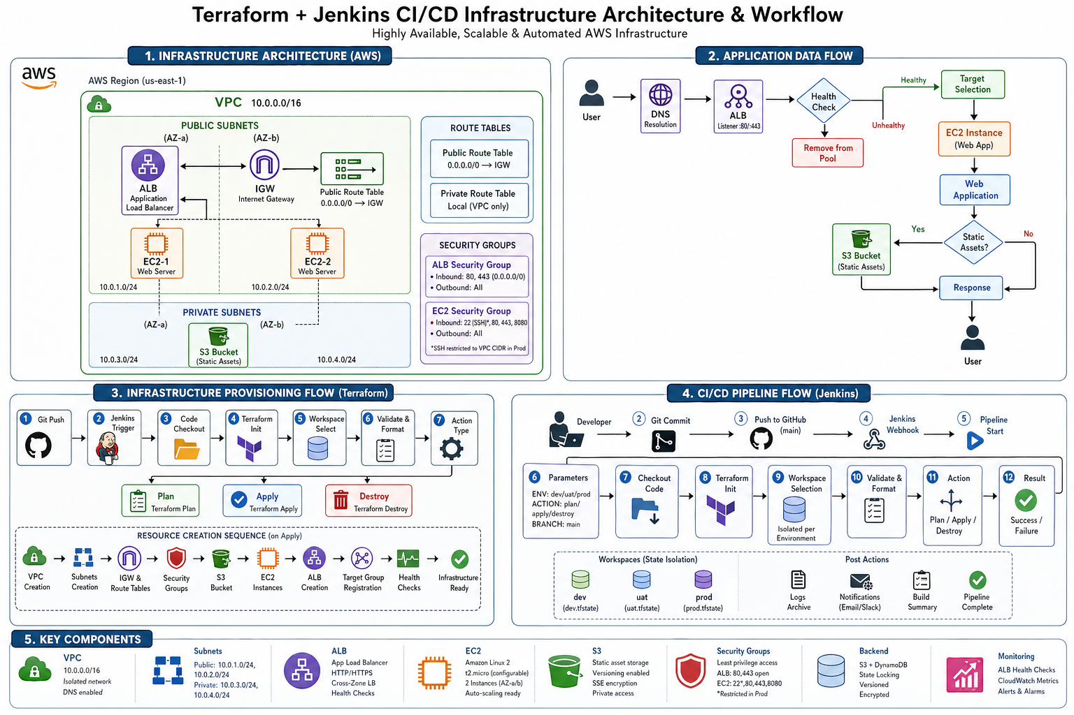

1. Project Overview
This project automates AWS infrastructure provisioning using Infrastructure as Code and CI/CD practices.
Technologies used:
- Terraform for infrastructure provisioning
- Jenkins for CI/CD automation
- Shell scripting for EC2 bootstrap
AWS services used:
- VPC
- Subnets
- EC2
- Application Load Balancer (ALB)
- S3
- Security Groups
The project supports multiple environments:
- dev
- uat
- prod

2. Folder Structure
project-root/
│
├── Script/
│ ├── apache2-script.sh
│ └── jenkins-terraform-script.sh
│
├── envs/
│ ├── dev.tfvars
│ ├── uat.tfvars
│ └── prod.tfvars
│
├── terraform-module-*/
│ ├── vpc/
│ ├── subnet/
│ ├── ec2/
│ ├── security-group/
│ ├── s3/
│ ├── alb/
│ └── igw/
│
├── main.tf
├── variables.tf
├── outputs.tf
├── backend.tf
└── Jenkinsfile

3. Scripts

3.1 apache2-script.sh
Used as EC2 user data script.
Functions:
- Updates system packages
- Installs Apache web server
- Starts Apache service
- Enables service on boot
- Creates a simple web page
Example output:
This is $(hostname)
Purpose: Helps identify EC2 instances behind the load balancer.

3.2 jenkins-terraform-script.sh

Jenkins Setup
- Installs Java
- Adds Jenkins repository
- Installs Jenkins
- Starts Jenkins service
- Displays admin password

Terraform Setup
- Installs Terraform
- Adds HashiCorp repository
- Verifies installation
Purpose: Prepares EC2 instance as Jenkins and Terraform server.

4. Environment Configuration
Location: envs/*.tfvars
Files:
- dev.tfvars
- uat.tfvars
- prod.tfvars
Each file defines:
- VPC CIDR block
- Subnet configuration
- EC2 configuration
- Resource tags
- S3 bucket naming
Key concept: Same Terraform code is reused across environments using different tfvars files.

5. Terraform Modules

5.1 VPC Module
Creates:
- VPC
- Internet Gateway
- Public Route Table

5.2 Subnet Module
Creates:
- Public subnets
- Private subnets
- Route table association for public subnets

5.3 Security Group Module
Allows:
- HTTP (80)
- HTTPS (443)
- Jenkins (8080)
- SSH (22)
Special logic: SSH access is restricted in production environment.

5.4 EC2 Module
Creates EC2 instances.
Feature:
- disable_api_termination enabled in production
Purpose: Protects production instances from accidental deletion.

5.5 S3 Module
Creates:
- S3 bucket
- Versioning
- Encryption
Special configuration:
- force_destroy is disabled in production
Purpose: Prevents accidental data loss.

5.6 ALB Module
Creates:
- Application Load Balancer
- Target Group
- Listener on port 80
- Registers EC2 instances

5.7 Internet Gateway Module
Creates Internet Gateway (optional use).

6. Main Terraform Configuration (main.tf)
This is the orchestration file.
Includes:
- AWS provider configuration
- Data source for latest Amazon Linux AMI
- Random ID for unique S3 bucket naming
- Local values for naming and tagging
Modules execution order:
- VPC
- Subnets
- Security Groups
- EC2 Instances
- S3 Bucket
- ALB
ALB logic:
- Uses public subnets
- Dynamically attaches EC2 instances

7. Outputs
Displays:
- VPC ID
- Subnet IDs
- EC2 instance IDs and public IPs
- S3 bucket name
- ALB DNS name
Purpose: Helps in validation and accessing deployed resources.

8. Variables
Defines:
- AWS region
- Environment name
- Subnet details
- EC2 configuration
- Tags
Validation: Only allows environments: dev, uat, prod.

9. Backend Configuration
Remote state management using:
- S3 bucket for storing Terraform state
- DynamoDB for state locking
Benefits:
- Prevents concurrent changes
- Avoids state corruption

10. Jenkins Pipeline
Defined in Jenkinsfile.

Parameters
- ENV: dev, uat, prod
- ACTION: plan, apply, destroy
- BRANCH: Git branch

Pipeline Stages
- Checkout
  - Pulls code from Git repository
- Terraform Init
  - Initializes backend
- Workspace
  - Creates or selects environment workspace
- Validate
  - Syntax and format validation
- Terraform Action
  - Executes plan, apply, or destroy

Post Actions
- Displays success message
- Displays failure message

11. Workflow
- Developer pushes code to Git repository
- Jenkins pulls latest code
- User selects environment and action
- Jenkins executes Terraform
- Infrastructure is provisioned automatically

12. Key Features
- Multi-environment support
- Modular Terraform design
- CI/CD automation using Jenkins
- Secure production configuration
- Dynamic infrastructure provisioning
- Load balancing with ALB
- Remote state management

13. Conclusion
This project represents a production-grade DevOps implementation showcasing:
- Infrastructure as Code
- Automation
- Scalability
- Environment isolation
- CI/CD integration

